ATAR Physics Year 11
Semester One Examination, 2016
Question/Answer Booklet

Student Name: ________SOLUTIONS_______________

Time allowed for this paper
Reading time before commencing work: 10 minutes
Working time for paper: 3 hours

Materials required/recommended for this paper
To be provided by the supervisor
This Question/Answer Booklet and the Formulae and Constants Sheet

To be provided by the candidate
Standard items: pens (blue/black preferred), pencils (including coloured), sharpener, correction tape/fluid, eraser, ruler, highlighters
Special items: non-programmable calculators approved for use in the WACE examinations, drawing templates, drawing compass and a protractor

Important note to candidates
No other items may be taken into the examination room. It is your responsibility to ensure that you do not have any unauthorised notes or other items of a non-personal nature in the examination room. If you have any unauthorised material with you, hand it to the supervisor before reading any further.

Structure of this paper
Section | Number of questions available | Number of questions to be answered | Suggested working time (minutes) | Marks available | Marks Attained
Section One: Short answers | 13 | 13 | 54 | 54 (30%) | /54
Section Two: Problem-solving | 7 | 7 | 90 | 90 (50%) | /90
Section Three: Comprehension | 2 | 2 | 36 | 36 (20%) | /36
 |  |  |  | 180 (100%) | /180

Instructions to candidates
Write your answers in the spaces provided beneath each question. The value of each question (out of 150) is shown following each question.

The enclosed Physics: Formulae and Constants Sheet may be removed from the booklet and used as required.

Calculators satisfying conditions set by the Curriculum Council may be used to evaluate numerical answers.

Answers to questions involving calculations should be evaluated and given in decimal form.
Give final answers to three significant figures and include appropriate units where applicable.

When calculating numerical answers, show your working or reasoning clearly. Despite an incorrect final answer, credit may be obtained for method and working, providing this is clearly and legibly set out.

Questions containing specific instructions to show working should be answered with a complete, logical, clear sequence of reasoning showing how the final answer was arrived at; correct answers which do not show working will not be awarded full marks.

Questions containing the instruction estimate may give insufficient numerical data for their solution. Students should provide appropriate figures to enable an approximate solution to be obtained. When estimating numerical answers, show your working or reasoning clearly. Give final answers to a maximum of two significant figures and include appropriate units where applicable.

Section One: Short answers (54 Marks)
This section has thirteen (13) questions. Answer all questions. Write your answers in the spaces provided.
Suggested working time: 54 minutes.

Question 1 (3 marks)
Convert each of the following values as indicated:
3.0 μC = 3000 nC
255 K = -18 °C
4.0015 amu = 6.6425 x 10⁻²⁷ kg

Question 2 (5 marks)


A cup of coffee is hotter than a warm bath, but the bath water can transfer more heat to its surroundings than the cup of coffee.
(a) At the molecular level, what does it mean when we say that the “cup of coffee is hotter than a warm bath”? (2 marks)

The coffee is at a higher temperature than the bath, so the water molecules in the coffee are moving faster (✔) and have a higher average kinetic energy (✔) than those in the bath

(b) Explain how the bath water can transfer more heat to its surroundings than the cup of coffee, even though it is at a lower temperature. (3 marks)

Even though the average kinetic energy of its molecules is lower than that of the coffee, the bath water contains many more molecules than the coffee (✔) and so its total internal energy is much higher (✔) and hence it can transfer much more heat as it cools to room temperature (✔) than the coffee can

Question 3 (4 marks)
Two charged balls, one positive and the other negative, are placed near one another as shown in the diagram below. Sketch the electric field in the region around the two charges AND draw arrows at points X and Y to show the electric force on a small positive charge placed at each of those points.
X
Y

Question 4 (4 marks)
A promising reaction that produces energy by nuclear fusion occurs between the nuclei of the two heavy isotopes of hydrogen - deuterium (D) and tritium (T). Calculate the amount of energy released during this reaction, which is shown below, given the following values of mass.
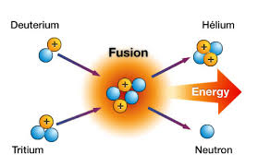
m (deuterium) = 3.34354 x 10⁻²⁷kg
m (tritium) = 5.00742 x 10⁻²⁷kg
m (helium-4) = 6.64473 x 10⁻²⁷kg
m (neutron) = 1.67496 x 10⁻²⁷kg

mass difference
= m(H-2) + m(H-3) - m(He-4) - m(n) ✔
= (3.34354 x 10⁻²⁷kg) + (5.00742 x 10⁻²⁷kg) – (6.64473 x 10⁻²⁷kg) – (1.67496 x 10⁻²⁷kg)
= 3.127 x 10⁻²⁹kg ✔
Hence E = mc² = (3.127 x 10⁻²⁹kg)(3 x 10⁸m/s)² ✔
= 2.8143 x 10⁻¹² J ✔

Question 5 (5 marks)
The resistance of a toaster increases as the heating element becomes hotter.
(a) Describe how the current through the heating element changes as the element heats up and briefly explain why this happens. (3 marks)

As the element heats up, the current through the element decreases ✔
This is because as the element heats up its atoms vibrate more vigourously within their lattice (✔), so electrons flowing through the element experience more collisions and so cannot pass through as easily ✔

(b) How large is the resistance of the heating element if a current of 5.00 A flows at the operating voltage of 240 V? (2 marks)

R = V/I = (240 V) / (5.00 A) ✔
= 48 Ω ✔

Question 6 (4 marks)
Compare the nature and charge of the three naturally occurring forms of nuclear radiation by filling in the missing cells in the table below.

Radiation | Nature – what is it? | Charge
α | Helium nucleus – 2 protons + 2 neutrons | +2
β | High speed electron | -1
γ | high frequency electromagnetic radiation | 0

Question 7 (4 marks)
Explain the following observations, using appropriate physics terminology.
(a) It feels colder standing barefoot on cement than on a mat in the same room. (2 marks)

The cement is a better conductor of heat than the mat (✔), so it absorbs heat from bare feet much more quickly than the mat (✔), leading to the perception that it is colder

(b) People suffering from hypothermia (extreme cold) are wrapped in shiny silvery blankets. (2 marks)

People suffering from hypothermia lose a lot of heat from their skin through emission of infrared radiation. (✔) The shiny silver blanket reflects this radiation back towards the person and minimizes heat losses through radiation. (✔)

Question 8 (4 marks)
Three 12 Ω resistors can be connected together in four different ways to give four different effective resistance values. Sketch the four different ways that the resistors can be arranged and state the effective resistance for each case.

3 resistors in series = 36 Ω ✔
3 resistors in parallel = 4 Ω ✔
2 resistors in parallel, followed by 1 resistor in series = 18 Ω ✔
2 resistors in series, in parallel with other resistor = 8 Ω ✔

Question 9 (4 marks)

A 12.0 V car battery is used to start the engine of a car, which, being cold and out of tune, only starts after 30 seconds of trying.
(a) If the starter motor draws an average current of 120 A during this time, calculate the total charge drawn from the battery in getting the engine to start. (2 marks)

q = I x t = 120 A x 30 s ✔
= 3600 C ✔

(b) Calculate the total energy supplied by the battery during this time. (2 marks)

E = q x V = 3600 C x 12.0 V ✔
= 43200 J ✔

Question 10 (4 marks)
Heat may be transferred by several mechanisms. A well-designed house should minimise heat transfer between the interior and the surroundings. State which of the mechanisms of heat transfer each of the following features has been designed to reduce.

Weather seals on doors convection ✔

Bulk insulation in the roof cavity conduction ✔

Eaves above windows radiation ✔

Pelmets above curtains convection ✔

Question 11 (5 marks)

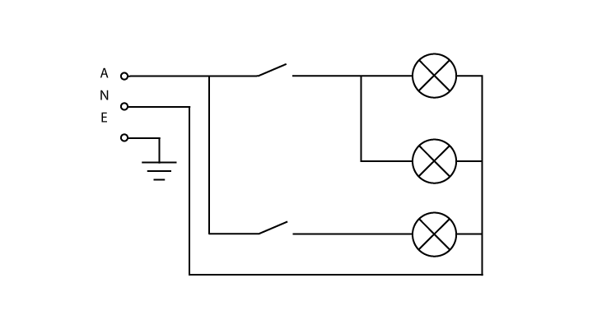
The diagram at right shows a domestic (240 V) lighting circuit that operates three 12 W light bulbs using two switches.
(a) Will more current flow when the top switch or the bottom switch is closed? Briefly explain your answer. (3 marks)

More current flows when the top switch is closed. ✔
The top switch allows two light bulbs in parallel to each receive full voltage from the power supply (✔), and hence the current drawn will be twice that drawn by a single bulb, and twice that drawn when the bottom switch is closed. ✔

(b) Calculate the total current drawn when both switches are closed so that all the light bulbs are in operation. (2 marks)

Each light bulb draws current I = P / V = (12 W) / (240 V) = 0.05 A ✔

Hence total current drawn is 3 x 0.05 A = 0.15 A ✔

Question 12 (4 marks)
A 75 kg worker in a nuclear power plant receives 0.30 J of energy from radiation in one year.
(a) What is their absorbed dose in milligray (mGy)? (2 marks)

Absorbed dose = E / m = (0.30 J) / (75 kg) ✔
= 0.004 Gy
= 4 mGy ✔

(b) Given that 50% of the absorbed dose was from fast neutrons and the other 50% was from gamma radiation, find their dose equivalent (in mSv). (2 marks)

Dose equivalent = (2 mGy x 10) + (2 mGy x 1) ✔
= 22 mSv ✔

Question 13 (4 marks)
The diagram below shows how refrigerant fluid is cycled around a typical car air-conditioning system.

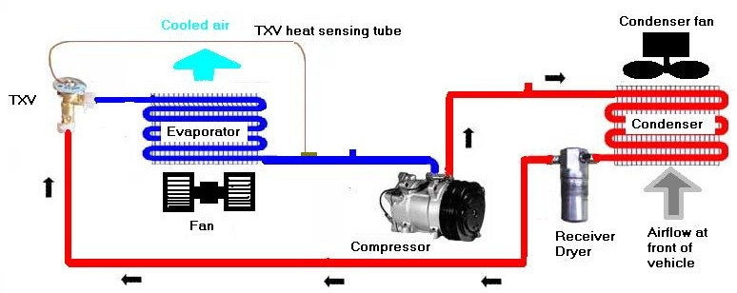

(a) Indicate the change in phase and the change in temperature of the refrigerant fluid after passing through the TXV (expansion valve) by circling your choice from the options below.

Phase change: condensation evaporation liquefaction (1 mark)

Temperature: stays same increases decreases (1 mark)

(b) Explain the following features of the evaporator and condenser coils, as shown above
(i) each coil is contained within a metal grid (1 mark)

The metal grid conducts heat rapidly to/from the coil and provides a large surface area from which heat can be transferred.

(ii) each coil has a fan helping move air over the coil (1 mark)

The fan increases convective heat transfer to/from the coil by continuously pushing air over the coil.

END OF SECTION ONE
Section Two: Problem Solving (90 Marks)
This section has seven (7) questions. Answer all questions. Write your answers in the spaces provided.
Suggested working time: 90 minutes.

Question 14 (14 marks)
A 12.0 volt battery is connected to a circuit as shown in the diagram below. The current flowing from the battery is 1.50 A while the current through resistor R₁ is 0.60 A.

12.0 V
R₂
6.0 Ω
R₁
4.0 Ω

X

Y

1.50 A
0.60 A

(a) State the current through the
(i) 4.0 Ω resistor 0.60 A (1 mark)

(ii) 6.0 Ω resistor 0.90 A (1 mark)

(b) Calculate the potential difference (voltage) between points X and Y. (2 marks)

V_{XY} = I x R = 0.90 A x 6.0 Ω ✔
= 5.4 V ✔

(c) Find the rate at which heat is produced in the 6.0 Ω resistor. (2 marks)

P = I² x R = (0.9 A)² x 6.0 Ω ✔
= 4.9 W ✔

(d) Find the value of resistor R₁ (3 marks)

V_{XY} = I x R = 0.6 A x (R₁ + 4 Ω) ✔
5.4 V / 0.6 A = R₁ + 4 Ω ✔
9 Ω = R₁ + 4 Ω
R₁ = 5 Ω ✔

(e) Find the value of resistor R₂ (2 marks)

Voltage drop across R₂ = 12.0 V - 5.4 V = 6.6 V ✔
Hence R₂ = V / I = (6.6 V) / (1.50 A) = 4.4 Ω ✔

(f) The resistors R₁ and R₂ are replaced with known values of 8.0 Ω  and 15.0 Ω respectively. What is the effective resistance of the whole circuit now? (3 marks)

Parallel section has resistance
1 / R_{p} = 1/6 + 1/(8 + 4) = 0.25 ✔
R_{p} = 4 Ω ✔
Effective resistance of the whole circuit is
R = 4 Ω + 15 Ω = 19 Ω ✔

Question 15 (11 marks)
The radioactive isotope carbon-14 is produced in the upper atmosphere when energetic neutrons from cosmic radiation collide with atoms of atmospheric nitrogen. The carbon-14 eventually undergoes beta decay back to nitrogen-14, over a time scale measured in thousands of years, as shown in the graph below. During this time the carbon-14 is absorbed by plants during photosynthesis and makes its way through the food chain, ultimately being absorbed by all living organisms.
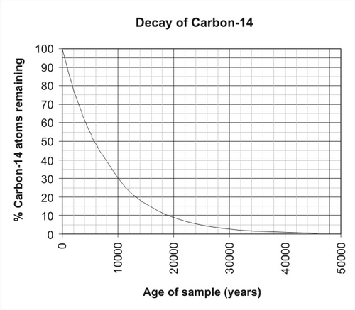

(a) Write balanced nuclear equations for
(i) the production of carbon-14 in the upper atmosphere (note: another particle is produced as a by-product each time a C-14 atom is formed) (2 marks)

¹⁴₇N + ¹₀n → ¹⁴₆C + ¹₁H
balanced equation ✔ proton produced ✔
(ii) the β decay of carbon-14 back to nitrogen (1 mark)

¹⁴₆C → ¹⁴₇N + ⁰₋₁e ✔

(b) Estimate the half-life of carbon-14, showing relevant working on the graph. (2 marks)

working shown on graph ✔
Half-life of about 5500 years ✔

(c) Carbon-14 dating is only effective up to a maximum age about 50,000 years. Using your value of half-life estimated above, calculate the percentage of carbon-14 atoms remaining after 50,000 years. (3 marks)

N = N₀ (1/2)^{x}
where N₀ = 100% and x = 50000 / 5500 = 9.09 half-lives ✔
Hence N = (100%) (1/2)^{9.09} ✔
= 0.2% ✔
(reasonable range of answers acceptable)

(d) Explain how the presence of the radioactive isotope carbon-14 can be used to date ancient human remains (such as bones). (3 marks)

A living organism, such as a human, interacts with its surroundings and takes in C-14 through food, maintaining a constant level of C-14 in its body. ✔
Once it dies, the level of C-14 in its body decreases exponentially due to radioactive decay (✔), and hence the amount of C-14 compared to the stable isotope C-12 indicates how much time has passed since the organism was alive and so can be used to date an organism’s remains. ✔

Question 16 (15 marks)
The graph below shows the heating curve for a sample of water that was heated in a sealed container from an initial state as very cold ice until all the water had been converted into steam. The various stages of the heating curve have been labeled with the letters a, b, c, d and e.

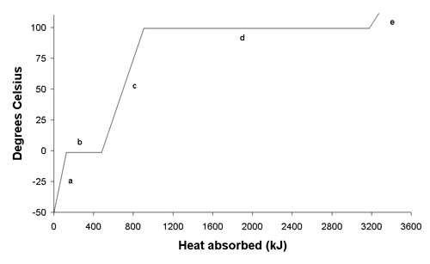

(a) Describe, in terms of the kinetic theory, what is happening to the water molecules as the sample of water absorbs heat during stage c. (2 marks)

During stage c the water increases in temperature as it absorbs heat. ✔
This means that the water molecules are increasing their average kinetic energy and moving faster, on average, as the water absorbs heat. ✔

(b) During stages b and d the water is being continually heated yet the temperature does not increase. Briefly explain what is happening during these two stages. (2 marks)

During stages b and d the water is changing phase as it absorbs heat. ✔
This means that the water molecules are increasing their potential energy by moving further apart from each other as the water absorbs heat. ✔

(c) Explain why the amount of heat absorbed during stage d is much larger than that absorbed during stage b. (2 marks)

The phase change during stage d is evaporation, compared to melting during stage b. (✔) Evaporation involves a much larger increase in separation between water molecules than melting, and so requires much more energy. ✔

(d) Explain why the gradient of the graph is steeper during stage a than stage c. (2 marks)

The specific heat of ice (stage a) is about half that of liquid water (stage c), (✔) so the temperature increases more rapidly as ice is steadily heated compared to liquid water, (✔) and hence the gradient of the graph is steeper during stage a than stage c

(e) From the graph estimate the quantity of heat absorbed during stage d and hence the mass of the water in the sealed container. (3 marks)

From the graph the quantity of heat absorbed during stage d is
Q = 3200 kJ - 900 kJ = 2300 kJ ✔
Q = m L m = Q / L (✔) = (2.3 x 10⁶ J) / (2.26 x 10⁶ J/kg)
= 1.0 kg ✔

(f) An evaporative air conditioner cools every cubic metre of air passing through it by evaporating 3.5 g of water from its filter. Given that the density of air is 1.275 kg per m³ and that air has a specific heat capacity of 1005 Jkg⁻¹K⁻¹, calculate the temperature drop experienced by every cubic metre of air passing through the air conditioner. (4 marks)

Heat absorbed when water evaporates from the filter is
Q = m L = 0.0035 kg x 2.26 x 10⁶ J/kg = 7910 J ✔
Every cubic metre of air has mass m = 1.275 kg (✔), so
Q = m c ΔT 7910 J = 1.275 kg x 1005 Jkg⁻¹K⁻¹ x ΔT ✔
Hence ΔT = 6.2 K ✔

Question 17 (11 marks)
switch
load
neutral
earth
active
The diagram at right shows the
typical way that an appliance
is connected to household wiring.

All appliances and lights within
a household are connected in
parallel to each other.

Electrical power is supplied
at 240 V via the meter box.

(a) What are two advantages of connecting household appliances in parallel, rather than in series? (2 marks)

- each appliance in parallel receives the full voltage of 240 V
- each appliance in parallel can be switched on or off independently of others

(b) Briefly explain the difference between the active wire and the neutral wire in a household circuit. (2 marks)

The active wire carries the full alternating voltage (240 V) from the power supply
The neutral wire completes the circuit by connecting to the ground (0 V)

(c) Why is a switch always placed on the active wire leading to an appliance, rather than on the neutral wire, given either position enables current flow to be stopped? (2 marks)

A switch placed on the active wire not only enables current flow to be stopped when opened, but it also disconnects the appliance from the power supply (✔), so the appliance is no longer live when switched off. ✔

(d) A domestic appliance is designed to produce 1200 W of power. What is its resistance when in operation? (2 marks)

P = V² / R R = V² / P ✔
= (240 V)² / (1200 W)
= 48 Ω ✔

(e) Explain the function of the earth wire that is connected to the metallic casing of an appliance. (3 marks)

The earth wire connects to the metal casing of an appliance so that in case of a fault where an active wire touches the casing and makes it live (✔), the earth wire provides a low resistance path to the ground, which will cause a large current to flow and trip the circuit breaker in the active wire (✔), cutting off power and preventing any chance of electric shock to a person who touches the casing. ✔

Question 18 (11 Marks)
The apparatus shown at right can be used to investigate the specific heat capacity of a liquid.
V
A
415 grams of an unknown liquid is carefully weighed out and poured into the beaker. An electric current is then passed through the heating element in the beaker for a period of 10.0 minutes.
During this time the voltmeter measures the potential difference across the heating element to be 11.2 V and the ammeter measures the current through the heating element to be 3.45 A.
A thermometer placed in the beaker shows that the temperature of the liquid increases from 21.5°C to 36.0°C during this time.

(a) Calculate the amount of heat energy produced by the heating element during the 10.0 minute period of heating. (3 marks)

E = V I t ✔
= (11.2 V) (3.45 A) (10.0 x 60s) ✔
= 2.32 x 10⁴ J ✔

(b) Determine a value for the specific heat capacity of the unknown liquid. (3 marks)

Heat energy absorbed by liquid is Q = 2.32 x 10⁴ J ✔
Q = m c ΔT 2.32 x 10⁴ J = (0.415 kg) c (36.0°C - 21.5°C) ✔
c = 3850 Jkg⁻¹K⁻¹ ✔

(c) Would you expect the actual value for the specific heat capacity of the unknown liquid to be larger or smaller than the value calculated above? Explain your answer. (3 marks)

Not all the heat energy produced by the heating element would be absorbed by the liquid; some would transfer to the surroundings. (✔) Hence the actual value of the heat Q in the equation Q = m c ΔT should be smaller while m and ΔT are unchanged. (✔) This would mean the actual value for the specific heat capacity of the unknown liquid is smaller than the value calculated above. ✔

(d) What practical modifications could be made to this experiment in order to get a more accurate value for the specific heat capacity of the unknown liquid? (2 marks)

- insulation around the beaker to prevent heat transfer
- more precise thermometers and multimeters
- an average calculated over repeated trials

(any 2 valid points)

Question 19 (13 marks)
One of the isotopes of thorium is Th-234, which is radioactive and undergoes alpha decay.

(a) Isotopes are atoms with (circle the correct option) (1 mark)
A the same mass number but different atomic numbers
B the same mass number and the same atomic number
C different mass numbers and different atomic numbers
D the same atomic number but different mass numbers ✔

(b) Write the nuclear equation for the alpha decay of thorium-234. (2 marks)

²³⁴₉₀Th → ²³⁰₈₈Ra + ⁴₂He
✔       ✔

(c) Calculate the mass defect of thorium-234, given the following masses: (2 marks)
thorium-234 = 233.98418u proton = 1.00728u neutron = 1.00867u

Mass defect Δm = 90 x m(p) + 144 x m(n) - m(Th-234) ✔
= (90 x 1.00728u) + (144 x 1.00867u) - 233.98418u
= 1.9195u ✔

(d) Find the binding energy per nucleon of thorium-234. (2 marks)

BE = 1.9195u x 931 MeV/u = 1787 MeV ✔
Hence BE/nucleon = 1787 MeV / 234 = 7.64 MeV ✔

(e) Briefly explain what is meant by the binding energy of a nucleus. (2 marks)

The binding energy of a nucleus is the energy released when a nucleus forms due to the strong force pulling the nucleons together. (✔) It therefore is the energy that must be provided in order to pull a nucleus apart working against the attraction of the strong force. ✔

(f) The graph below shows the binding energy per nucleon against number of nucleons (mass number) for a wide range of isotopes spread across the periodic table.

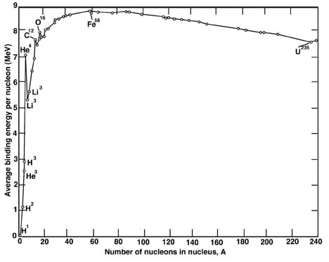

With reference to the graph, state whether or not the following statements are True (T) or False (F).

(i) Binding energy per nucleon is a measure of the stability of a nucleus ___ T ___ (1 mark)

(ii) A carbon-12 nucleus is more stable than a tin-120 nucleus ____ F ____ (1 mark)

(iii) The fusion of 4 protons (H-1) into helium-4 releases about 28 MeV ___ T ____ (1 mark)

(iv) Fission of nuclei with mass number greater than 56 absorbs energy ____ F ____ (1 mark)

Question 20 (15 marks)
A common type of solar hot water system is the close-coupled thermosyphon shown in the diagram below. It consists of a flat plate collector containing an insulated black metal absorber plate, which typically has an area of about 4 m². Water flows through copper tubes embedded in the surface of the absorber plate. Above the plate is a layer of air trapped beneath a flat glass cover. Solar energy is absorbed by the water in the tubes. The warm water enters the storage tank, which is located at the top of the system and usually has a capacity of about 300 L. Solar radiation in Perth has an average intensity of about 600 W/m² on a clear spring day over 12 hours of sunlight.

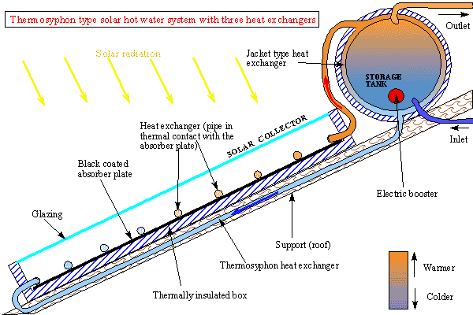

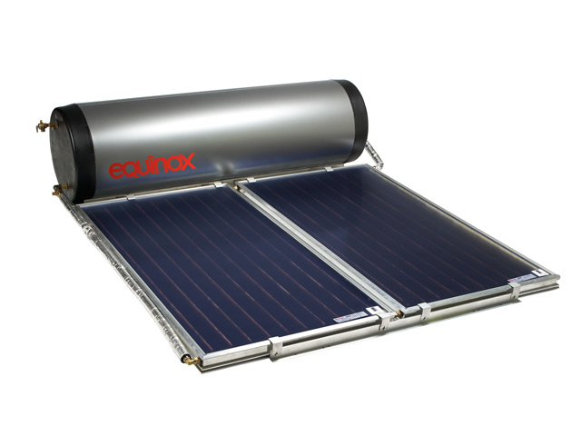

(a) Briefly explain how each of the following features of the collector plate allows for the maximum transfer of solar energy into thermal energy in the water:
(i) the collector plate contains a black coated metal absorber plate (2 marks)

The black coating on the absorber plate is the best colour for absorbing solar radiation (✔) and hence transferring the maximum amount of energy from the solar radiation into heat energy in the absorber plate. ✔

(ii) the copper pipes are embedded in the surface of the absorber plate (2 marks)

Metals are good conductors of heat, (✔) so by embedding the copper pipes in the surface of the metal absorber plate the maximum transfer of heat by conduction can occur. ✔

(b) Explain how the glass cover over the collector plate helps minimise heat loss. (2 marks)

The glass cover helps minimise heat loss by
- preventing re-radiated infrared from escaping and thus minimising heat losses by radiation ✔
- trapping hot air rising away from the collector plate and thus minimising heat losses by convection ✔

(c) In order to get maximum benefit from the system, the flat plate collectors are positioned on a north facing roof and angled so as to present maximum area to the winter sun. Why would the collector plate be angled so as to present maximum area to the winter sun? (2 marks)

Solar radiation is not as intense in winter, and the hours of sunshine are much shorter, (✔) so it is important to optimise the heating of water in winter rather than other seasons when the days are longer and radiation more intense. ✔

(d) Why is a pump is not needed to move the water through the system? (2 marks)

A convection current is set up in the system due to the difference in water temperature at different parts of the system. (✔) As water in the pipes in the collector plate is heated it decreases in density and so tends to rise through the system into the storage tank at the top, while cooler, denser water replaces it at the bottom of the system. ✔

(e) If the water in the tank is initially at 15°C, calculate the final temperature of the water in a typical system after 12 hours of heating on a clear spring day, given that the solar hot water system is 60% efficient. (5 marks)

Effective power of the hot water system on a clear spring day is
P = (600 W/m²) x (4 m²) x 60% = 1440 W ✔
Heat absorbed by the hot water system after 12 hours on a clear spring day is
Q = P x t = 1440 W x (12 x 60 x 60 s) = 62 MJ ✔
This heat is absorbed by the 300 L in the storage tank, so
Q = m c ΔT 6.2 x 10⁷ J = (300 kg)(4180 J/kg/K) ΔT ✔
ΔT = 50 K ✔
 is 15°C + 50°C = 65°C ✔

END OF SECTION TWO
Section Three: Comprehension (36 Marks)
This section has two (2) questions. Write your answers in the spaces provided.
Suggested working time: 36 minutes.

Question 21 OMHIC/NONOHMIC CIRCUIT COMPONENTS (16 marks)
A Year 11 student carried out an experiment that measured the current through a particular circuit component, identified only as component X, as the voltage across it was successively increased. She then repeated the experiment for a second circuit component, identified only as component Y. The tables below show the data collected in the experiment by the student.

Component X |  | Component Y
Voltage (V) | Current (A) | Voltage (V) | Current (A)
2.12 | 0.14 | 2.05 | 0.24
3.95 | 0.27 | 3.86 | 0.41
5.78 | 0.39 | 5.68 | 0.53
7.69 | 0.53 | 7.43 | 0.63
9.56 | 0.64 | 9.25 | 0.71
11.45 | 0.75 | 11.20 | 0.79

(a) On the graph paper supplied on the next page, draw a graph of voltage versus current for each component, using the same set of axes. (5 marks)
uniform scales + labeled axes ✔
Component X: plotted points ✔ + line of best fit ✔
Component Y: plotted points ✔ + curve of best fit ✔

(b) Which of the two components is an ohmic conductor? Calculate its resistance from your graph. (3 marks)

Component X is ohmic as it has a linear graph ✔
Resistance (X) = gradient = (7.5 – 0)V / (0.5 – 0)A ✔
= 15 Ω ✔

(c) What is the appropriate number of significant figures for your calculated value of resistance for the ohmic conductor? Briefly state why this is the appropriate number of significant figures. (2 marks)

2 sig figs (✔), as the current values used to find resistance were only measured to 2 sig figs ✔

V vs I for component X

V vs I for component Y

(d) Could you use your calculated value of resistance to predict the current through the ohmic conductor if a voltage of 25.00 V was applied across it? Briefly explain. (2 marks)

No (✔) , as this voltage is beyond the range of the data and the conductor may no longer be ohmic for this large voltage ✔

(e) From the graph, find the resistance of the nonohmic conductor when the voltage across it is
(i) 6.0 V (1 mark)

R = 6.0 V / 0.55 A = 11 Ω

(ii) 12.0 V (1 mark)

R = 12.0 V / 0.82 A = 15 Ω

(f) Which of these estimated values of the resistance of the nonohmic conductor do you think is more reliable? Briefly explain your reasoning. (2 marks)

The resistance of 11 Ω, calculated at V = 6.0 V, (✔) is more reliable as it is estimated from within the range of the data (interpolated), whereas the value of 15 Ω has been estimated from outside of the range of the data (extrapolated) ✔

Question 22 NUCLEAR POWER (20 marks)
(Paragraph 1)
Uranium-235 is one of the few materials that can undergo nuclear fission. If a free neutron collides with a U-235 nucleus, the nucleus can absorb the neutron, become unstable and split immediately into two lighter nuclei, throwing off two or three new neutrons (the number of ejected neutrons depends on how the U-235 nucleus happens to split). The two new nuclei then release beta and gamma radiation as they settle into their new states.

(Paragraph 2)
An incredible amount of energy is released, in the form of heat and radiation, when a single U-235 nucleus splits. The energy released comes from the fact that the fission products and the neutrons, together, weigh less than the original U-235 nucleus. The difference in mass is converted directly to energy at a rate governed by Einstein’s equation E = mc² and is of the order of 200 MeV (million electron volts) per fission.

(Paragraph 3)
To fuel a nuclear reactor, natural uranium must be enriched so that it contains 3 percent or more of U-235. The enriched uranium is formed into pellets, which are arranged into long rods, and the rods are collected together into bundles. The bundles are then typically submerged in water inside the reactor core. The uranium bundles act as an extremely high-energy source of heat. They heat the water and turn it into steam, which drives a steam turbine, and spins a generator to produce power.

(Paragraph 4)
The probability of a U-235 nucleus capturing a neutron depends on the speed of the neutron. A material called the moderator is present in the core of a nuclear reactor (usually water, or sometimes graphite) to slow down ejected neutrons and increase their probability of subsequent capture.

(Paragraph 5)
Control rods made of a material that absorbs neutrons, such as boron steel, are inserted into the reactor core using a mechanism that can raise or lower the control rods. Raising or lowering the control rods allows operators to control the rate of the nuclear reaction. When an operator wants the uranium core to produce more heat, the rods are raised out of the uranium bundle; to create less heat, the rods are lowered into the uranium bundle. In a reactor working properly (known as the critical state), one neutron ejected from each fission causes another fission to occur. The rods can also be lowered completely into the uranium bundle to shut the reactor down in the case of an accident or to change the fuel.

(Paragraph 6)
The reactor core is typically housed inside a concrete liner within a much larger steel containment vessel that is designed to prevent leakage of any radioactive gases or fluids. An outer concrete building that is strong enough to survive impact by crashing jet airliners protects the steel containment vessel. The absence of secondary containment structures in Russian nuclear power plants allowed radioactive material to escape at Chernobyl.

(Paragraph 7)
Uranium-235 is not the only possible fuel for a power plant. Another fissionable material is the artificial isotope plutonium-239. Pu-239 can be created easily from U-238 by bombarding it with neutrons - something that happens all the time in a nuclear reactor - in a 3-step process that involves the neutron bombardment of U-238 followed by successive beta decays that convert the uranium nucleus into a plutonium nucleus.
(a) One of the possible fission reactions for a U-235 nucleus is where it absorbs a neutron and splits into a barium-142 nucleus and a krypton-91 nucleus. Write the balanced nuclear equation for this fission reaction. (2 marks)

²³⁵₉₂U + ¹₀n → ¹⁴²₅₆Ba + ⁹¹₃₆Kr + 3 ¹₀n

balanced equation ✔ 3 neutrons produ ✔

(b) One kilogram of uranium-235 contains approximately 2.5 x 10²⁴ nuclei. Use information provided in paragraph 2 to estimate the
(i) energy released (in joules) if a kilogram of uranium-235 underwent fission. (3 marks)

200 MeV of energy are released per fission of a nucleus (✔) , so energy released if a kilogram of uranium-235 underwent fission is
E = 200 MeV/nucleus x 2.5 x 10²⁴ nuclei ✔
= 5 x 10²⁶ MeV x 1.6 x 10⁻¹³ J/MeV
= 8 x 10¹³ J ✔

(ii) difference in mass between the kilogram of uranium-235 undergoing fission and the fission products. (2 marks)

E = Δm c² 8 x 10¹³ = Δm (3 x 10⁸ m/s)² ✔
Δm = 8.9 x 10⁻⁴ kg ✔

(c) In a typical nuclear power plant the fuel rods are submerged in water. Describe two functions the water may serve in the operation of the reactor. (4 marks)

- the water may act as a coolant (✔) , removing heat from the reactor core ✔
- the water may act as a moderator (✔) , slowing down the neutrons to enhance the rate of fission ✔

(d) Briefly explain what is meant by each of the following terms.
enrichment (paragraph 3) (2 marks)

Enrichment is the procedure whereby natural uranium is processed to increase the proportion of the fissile isotope U-235 (✔) , to a level where it contains 3% or more of U-235 ✔

critical state (paragraph 5) (2 marks)

Critical state refers to a steady rate of fission reaction (✔) where one neutron from each fission causes another fission to occur ✔

(e) State the purpose of the
control rods (2 marks)

The control rods absorb neutrons in the reactor core (✔) , and by being raised from or lowered into the reactor core are able to vary the rate of the fission reaction ✔

steel containment vessel (1 mark)

The steel containment vessel is designed to prevent leakage of any radioactive gases or fluids from the reactor ✔

(f) Plutonium-239 can be produced from uranium-238 in a nuclear reactor, after the absorption of a neutron by the uranium-238, in a three step process. Show the two intermediate nuclides that are involved in this process. (2 marks)

U-238 → U-239 → Np-239 → Pu-239
✔ ✔

END OF PAPER
EXTRA WORKING SPACE

EXTRA GRAPH PAPER

